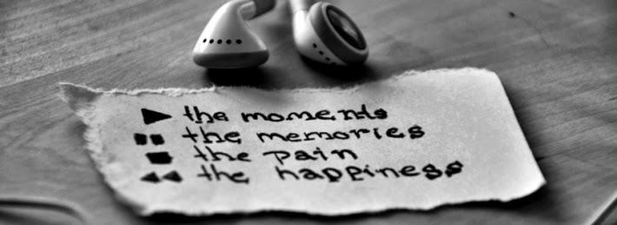

**Music and Memories**

The Alzheimer society has a program called music and memories. They create a playlist of music from a client’s life that can be used to stimulate memories. Think about this for a moment, the memories attached to the music, like the theme song for your life. Cool, no?

**What about those memories?**

I’m sure you can think of some great moments in your life and the music that was playing in the background connected with that moment. Not all those memories are happy ones. We’d all love to be done with those but, what about those happy ones?

Happy memories can be even more problematic. Think of this, that song that brings you back to that high school romance, your first love, the one you’ve used as a yardstick for everything that followed. Nothing has ever measured up to that memory, could that be a limitation, happiness denied because nothing is like that first love?

A couple of lyrics come to mind here, I can’t place the songs, I think Garth Brooks, ‘thank god for unanswered prayers’ and ‘what’s she doing now’ on the one hand the song is of a high school reunion and seeing the high school sweetheart from adult eyes. The other, is of regret for a lost love, stuck in this place of wondering. Neither allows space for something else, does it? Good or bad, both have the same stuck-ness.

**Where are you stuck in your life?**

I can think of a few songs that trigger memories, both good and bad. As a wee child we had an aunt living with us, unwed and pregnant in an era where that was a mortal sin. Funny but the song looping in my head is ‘I never promised you a rose garden’. Of course there are a few others, every time I heard Fleetwood Mac’s Rumours, I think of a near death experience on a mountain road and a dramatic tire blowout.

**What to do?**

So, the whole point of my wander down memory lane? Well, we can shift the stuck-ness, even if it doesn’t feel like a stuck-ness. Gather up those musical moments, create a playlist if you are so inspired, go into those stories threading through the music of your life and tap. Simple and effective, be in the memories connected with the music... let it take you back and while you’re there tap through the energy. It’s like an interrupt for the electrical signals running through your body, disconnecting the music from the emotional intensity of the memories. You can continue to enjoy the music, you can continue to have those memories but with the emotional intensity gone, you can begin to see more, see the stuff that was blocked by the intensity that keeps you stuck in that loop.

With that flat tire experience, I remember what a beautiful day it was and how much fun I was having, an outdoor wilderness adventure. I’d forgotten the other great stuff that had happened that day. Now the music is attached to a wonderful outdoor adventure, not stuck at that one moment in time. Now, I wonder what other music I can tap through.

**In Conclusion**

While you’re playing, remember this, be kind to yourself. Trust your innate wisdom and honour what is coming up for you. If you find yourself facing a challenge, seek out an accredited practitioner who will honour you.

Working with an experienced practitioner can make the journey easier, more fulfilling and smooth out the bumps along the road. Don’t hesitate to seek out the help of a professional who will honour you in the process.

Are you ready to begin this healing dance? Is it time to choose something different? Change can be as simple as making the choice and asking, what else is possible?

To get started, check out my websites, [www.eftenergyhealth.com](http://www.eftenergyhealth.yolasite.com) or [www.accesshealthyenergy.com](http://www.accesshealthyenergy.com) to book a session or come to a workshop.

Like my facebook page, <https://www.facebook.com/EftEnergyHealth> and explore.

Healing doesn’t have to be all doom and gloom. Choose to have some fun with it. Whatever isn’t working, kick that sucker to the curb and allow something wonderful to show up in your life. Know this, no matter what, you are enough.

Katherine