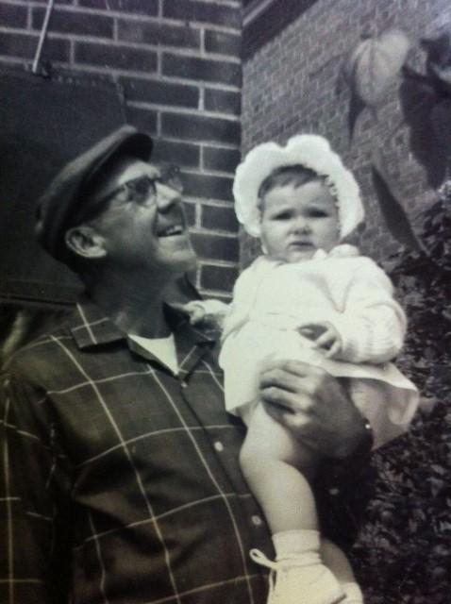 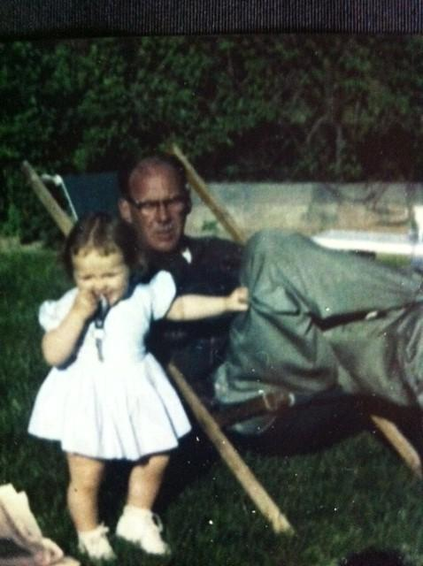 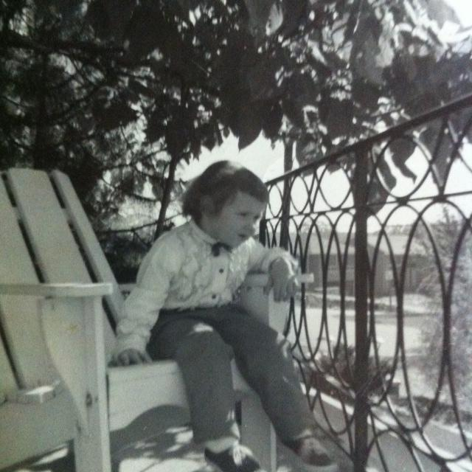

I've been circling around this for a while now, and it's a story that so dearly wants to be expressed.

I've always known what an influence the female role models had on who I became; it was a mixed bag of emotions, observations and contrasts.

Only recently did I get an insight into the impact of my grandpa on who I became and while my grandparents were a unit and I've always thought of them as a unit and known the role they played in my becoming me, I saw another layer and felt it at a different level.

Doing personal work is always a mixed bag, as you go deeper it seems more abstract and visceral. Recently I was doing some work on love, and I mean the kind of big love, divine, universal, god like love that comes from seeing the divine in everyone, so it surprised me where it went.

Suddenly I was seeing the child I was and I mean a little girl, pre-verbal; pre-school, in the place of utter peace and love and contentment, at my grandfather's side as he puttered around the property, patching mortar, of all things, I (the girl not the meditator) was observing, feeling, connecting, forming the concept of who I became; listening to adult discussions in the living room on current events, engaging discussions on politics, religion and the general state of the world; sitting on the Adirondack chairs my grandfather built (they didn't know Muskoka back then) while he read the newspaper, something he did daily. He'd come home from work, pour a beer and read the paper. As he did, he'd talk about what he was reading and we'd discuss it, these discussions and the definition of family that it gave me, created my desire to engage in the world, create a family of my own, explore and question everything. It was a place of love, a space of peace and contentment with a focus on family, nurturing and caring for your stuff.

I've always known it was my refuge from the chaos of the world but until recently, I didn't grasp how wholly if defined me, but more than that, I could perceive the little girl I was, observing, feeling and choosing who I would become in this world.

Knowing it was a choice who I became and not something compelled by DNA or any other factors, I can choose to be that or something different. I won't be dishonouring anyone for making a different choice; I keep the love with me no matter what, that is the most precious gift from this awareness.

Katherine

[www.accesshealthyenergy.com](http://www.accesshealthyenergy.com)