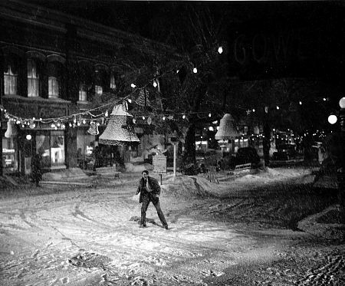 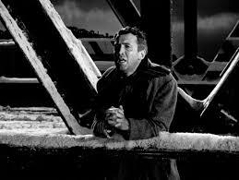 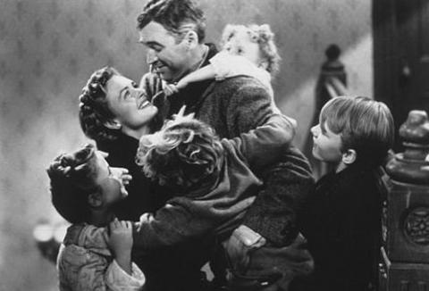

**Being and Nothingness**

Did that get your attention? With this whole Trump/Clinton thing behind us, it looks like everyone has jumped into Christmas with an unprecedented fervour. It got me thinking and a funny thing happened. ‘It’s a Wonderful Life’ popped into my head. With so many Christmas specials out there, you may not have seen or heard of this one. The movie is a gem. I suggest you find a copy and watch, it’s not just a Christmas classic, watch it when you need a boost. Let me explain.

**Hollywood gets it right**

It’s a Wonderful Life is a story about an ordinary man going through the ordinary business of his very ordinary life in a small town. Events happen that lead him to a crisis point in his life and in his desperation he believes that everyone would be better off if he ended his life. Thanks to the magic of Hollywood, an angel appears and shows him what would have been, had he not existed. He sees how his being on the planet has affected the lives of everyone in his community.

We all want to be an Elon Musk, David Wolfe, Obama/Trump/Clinton centre stage, creating and changing the world in powerful and dramatic ways, having an impact on the planet. But, what if you being you is changing the world? That is the message of this movie, an ordinary man, an ordinary life and his beingness is changing the world. His existence is enough, he is enough, that he exists is all that is required, flaws, ordinariness and all.

**You are enough**

I challenge you to a different perspective. I’ll ask you to see the contribution you be, just by being you, to see you are enough, no matter the events or imperfections in your reality. Just being you is a gift and it is enough. To know that is the greatest gift you can give yourself.

**In Conclusion**

As always, be kind to yourself. Invest in the best healing you can and remember this; honour what is coming up for you. Trust your innate wisdom.

Working with an experienced practitioner can make the journey easier, more fulfilling and smooth out the bumps along the road. Don’t hesitate to seek out the help of a professional who will honour you in the process.

Are you ready to begin this healing dance? Is it time to choose something different? Change can be as simple as making the choice and asking, what else is possible?

To get started, check out my websites, [www.eftenergyhealth.com](http://www.eftenergyhealth.yolasite.com) or [www.accesshealthyenergy.com](http://www.accesshealthyenergy.com) to book a session or come to a workshop.

Like my facebook page, <https://www.facebook.com/EftEnergyHealth> and explore.

Healing doesn’t have to be all doom and gloom. Choose to have some fun with it. Whatever isn’t working, kick that sucker to the curb and allow something wonderful to show up in your life. Know this, no matter what, you are enough.

Katherine